

American International University-Bangladesh (AIUB)  
**Department of Computer Science  
Faculty of Science &Technology (FST)  
Fall 22 23**

**Travel Management System**

Software Requirement Engineering

Sec: **B**

Project submitted

By

*S M Tusher Mustakim (19-40861-2)*

*MD. Shalim Sadman (20-42303-1)*

*Shuvro Kumar Saha (20-43536-1)*

*Kazi Shifatur Rahman(20-42593-1)*

**Checked By Industry Personnel**

Name: Saif Hassan

Designation: Lead Product Manager

Company: weDevs

Sign:

Date:

**Table of Content**

1. Problem Domain ………………………………………………….…….….1
   1. Background to the problem …………………………………….1
   2. Solution to the problem ………………………………….…..…2
2. Solution Description ……………………………………………...………..3
   1. System Features ………………………………………….......….3
   2. UML Diagrams ……………………………………………….…4
3. Social Impact ………………………………………………………………7
4. Development Plan with Project Schedule ……………………...............…..9
5. Marketing Plan …………………………………………………………….11
   1. Short Term Plan …………………………………...………..11
   2. Long-Term Plan …………………………………….………12
   3. Continuous Plan……………………………………….……..12
   4. SWOT Analysis…………………………………….………...13
6. Cost and Profit Analysis …………………………………………….…….16
7. References ……………………………………………..………………….19

**1. Problem Domain:**

**1.1 Background to the Problem**

A person with so much work load in his daily life who want to make a proper tour

plan & manage everything during traveling is not easy always. Sometimes it is

difficult to get proper information & make the best tour plan for those people. Some

people have less idea or don’t have any tourmate if he able to gain some knowledge

about planning a tour. It’s also hard to find the option to customize the tour plan as

all the agencies give anyone a fixed plan. Sometimes people can’t go for a tour for

budget issues or don’t have a proper knowledge about budgeting. Reliability issue

occur if the agency sent someone with a group of people if he doesn’t know them.

All facilities are not available in one site including transport, hotel, food, etc.

A person always wants to get some refreshment during his leisure time. People who

like travelling go for a tour during vacations. But many often some bad experience

makes them demotivate about travelling. Sometimes they didn’t get times for plan a

tour because of having a heavy workload in daily life. The contact any agency and

they send them with a couple of people which they don’t know. But if he wants to

go alone or wants to go with a limited number of people that’s not happen because

of high costing.

**1.2 Solution to the Problem**

A website with all the information a user needs to plan a tour or go for any area for

travelling. There will be various packages to get the best travel experience. Users

will have the opportunity to customize the tour plan as per their needs. From the

transport he/she want to travel to the hotel he/she wants to stay in and a variety of

activities that are available in those places, if any guide needed for the road the user

wants to travel, everything will be included in the website. User reliability will be

ensured by verifying all user’s identities. Transport, hotel, food, and all other things

during traveling will be managed by us. As there is no such website giving all

the facilities, we are promised to provide this can be an appropriate solution for the

user.

The software we want to propose is named ‘GhuraGhuri’. A busy person or a person

with zero knowledge about tour planning or traveling can use the specific software

and get benefits. Even a person who never visited a place before can be benefited

from the proposed solution. All the needs of a person when he/she went for a tour can be

included in this solution, so that both the tourism sector and the user can be benefited

by the proposed solution. By this the foreigner may get a positive vibe about our

country and feel more interested to visit the country.

There are some existing solutions for the problem like ‘sharetrip.net’ provides a user

with various package of travelling. But they only provide the flight facility with hotel and

other activities. ‘Pathfriend tour operator’ provide a tour plan with fixed packages.

‘NijhoomtTours’ is also a website who provides a user will tour under a fixed

package which they provide.

**2. Solution Description:**

**2.1 System Features**

Admin Requirements:

❖ The admin can add new packages.

❖ The admin can update any package.

❖ The admin can delete any package.

❖ The admin can search any package

❖ The admin can monitor daily profit/loss by graph

❖ The admin can also change his name or password from the

dashboard settings.

End User Requirements:

❖ The end users book tour plan according to their choice.

❖ User share their feedback with comments.

❖ The user can sign up after filling all the fields mentioned in the

sign-up form.

❖ The user can login after validation of his/her details from the

database.

❖ The end users can reserve their seats for tour plan which they

choose or like.

❖ The client can find the information and the calculate system of

time, ways

❖ The client can see private history with analyses with booking,

transport, price, time, etc. And keep or share the information

❖ The client can see whether of each area inside map or place that

they want

System Requirements:

❖ Travel management system offer logout functionality to end

users.

❖ Travel management system will only accept a valid login detail to

enroll on a travel Management System in PHP.

❖ Travel management system will provide password recovery

facility.

❖ Travel management system will redirect the user to WhatsApp

whenever the WhatsApp icon is pressed for online payment

purposes

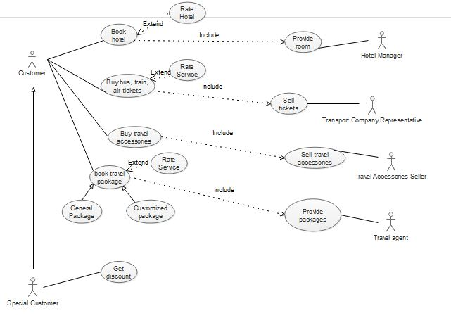**2.2 UML Diagrams:**

Figure 1: Use Case Diagram

User Case Diagram: In this use case diagram there are six actors. The hotel manager can provide rooms and customers can book rooms in the hotel. Similarly, transport company, and travel accessories seller provides some services to the customer. Travel agents provide packages to customers and control all over the system. Special customers can get a discount in this case.

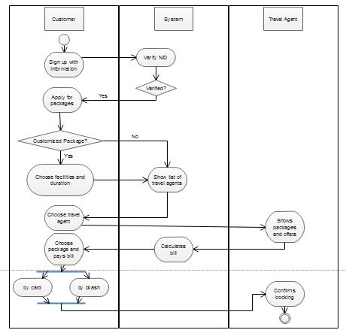

Figure 2: Activity Diagram

Activity Diagram: In this diagram, all the activity by the customer and travel agent has been shown. When a customer signs in the system will verify and show the dashboard to the customer. After that, if the customer goes for the packages option and wants to customize his package the system will show the list of packages that has been assigned by the travel agent or admin. After choosing hotels, transportation, and others the customer can see the calculated bill instantly and go for checkout. Customers can pay the bill by bank account/card or mobile banking.

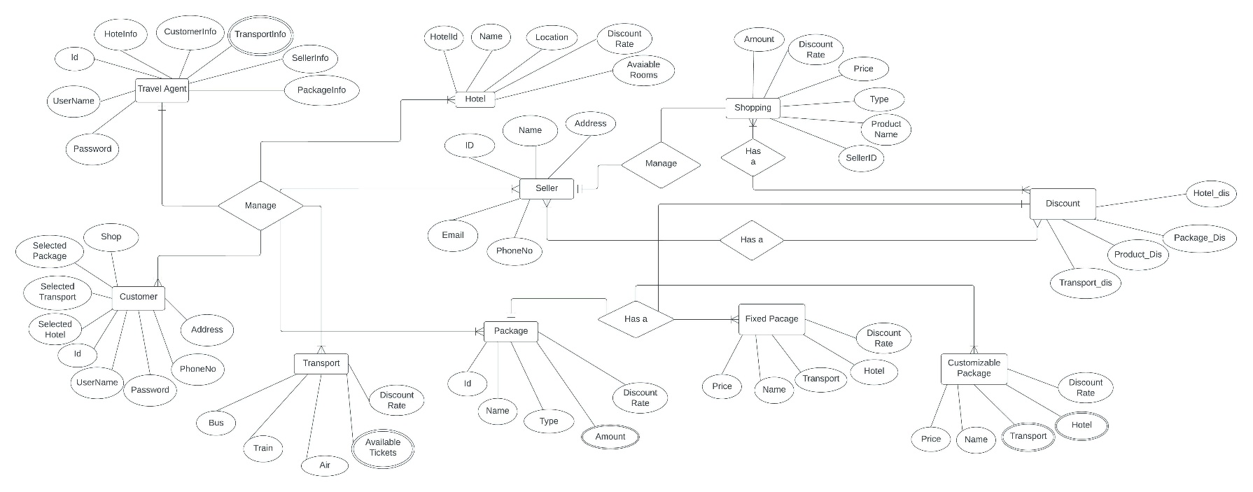

Figure 3 : E-R Diagram

E-R Diagram: There are eight entities in this project. The entities have a relationship with each other. Some entities like a travel agent transport have one too many relationships. Because travel may be contacts of many types of transport company or officials. There are also some many-to-many relationships like many sellers can have many discounts. Also, the relationship may be Has a relation or manage relation. All the relations have defined in the E-R diagram.

**3. Social Impact:**

Travel management software is no longer exclusively for big businesses. Instead of booking on consumer sites and having difficulty locating invoices, small and medium-sized businesses gain a lot when they manage their travel using software created for businesses.

We cover all you need to know about essential features, vendor options, and the market as a whole, whether you have used travel management software for a while or are just starting to look into this type of software.

**A. Enhanced employee productivity:**

Organizations that do away with these antiquated travel and management practices relieve their staff members, who can then devote all of the time spent planning their business travels to their jobs.

**B. Reduction of travel expenses:**

Such a corporate program's visibility will enable businesses to better understand the travel spending and spending patterns of their employees, spot trends and patterns, and ultimately devise analytical strategies to rein in excessive travel expenses.

**C. Reduce the risks associated with travel and spending management:**

Procedures like invoice verification and invoicing become more effective and less prone to expensive mistakes. When you incorporate cloud services and other automated tools into your travel and expense management strategy, it is simpler to carry out audits without making mistakes, which enables the business to give external auditors the data they require and keeps you in compliance.

**D. less personnel to support:**

In the end, such an automated solution enables businesses to cut down on the time staff members spend overseeing and assisting various travel-related activities. Your business should invest strategically in automated travel and cost management for a number of important reasons. I'm hoping you'll be inspired to start a movement for change that everyone will be proud of.

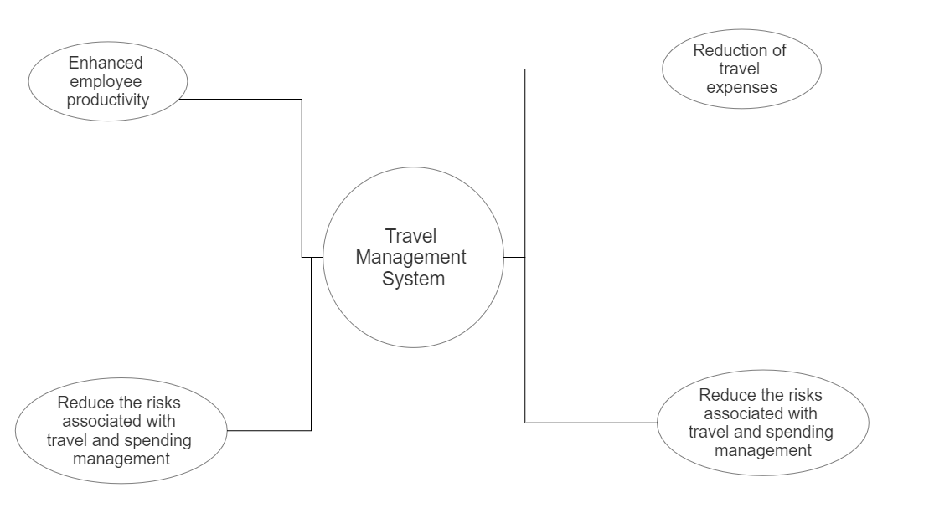

Figure 4 : Social Impact

**4. Development Plan with Project Schedule:**

**Development Plan:**

❖ Identify and meet with stakeholders

❖ Set and prioritize goals

❖ Define deliverables

❖ Create the project schedule

❖ Create a budget

❖ Add milestones

❖ Identify issues and complete a risk assessment

❖ Present the project plan to stakeholders

**Project schedule:**

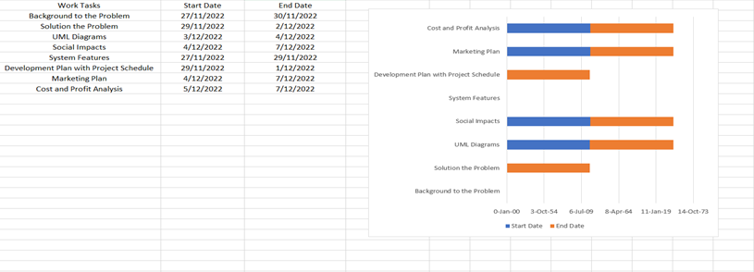

|  |  |  |
| --- | --- | --- |
| **Weeks**  **Travel Management**  **System**  **: Person** | **Week-1**  **(27/11/2022**  **To**  **03/11/2022)** | **Week-2**  **(4/12/2022**  **To**  **10/12/2022)** |
| A: S M TUSHER MUSTAKIM |  |  |
| B: MD. SHALIM SADMAN |  | V |
| C: SHUVRO KUMAR SAHA |  |  |
| D: KAZI SHIFATUR RAHMAN |  |  |

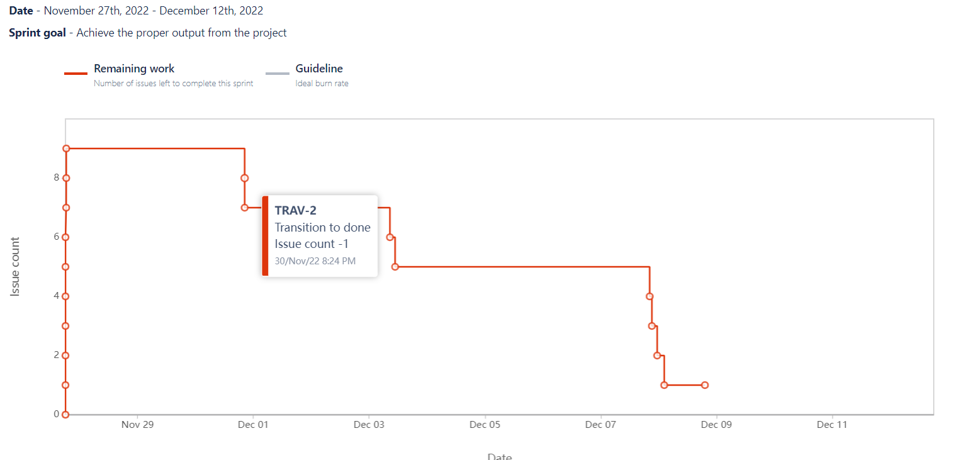

Figure 5 : Management Tool Report

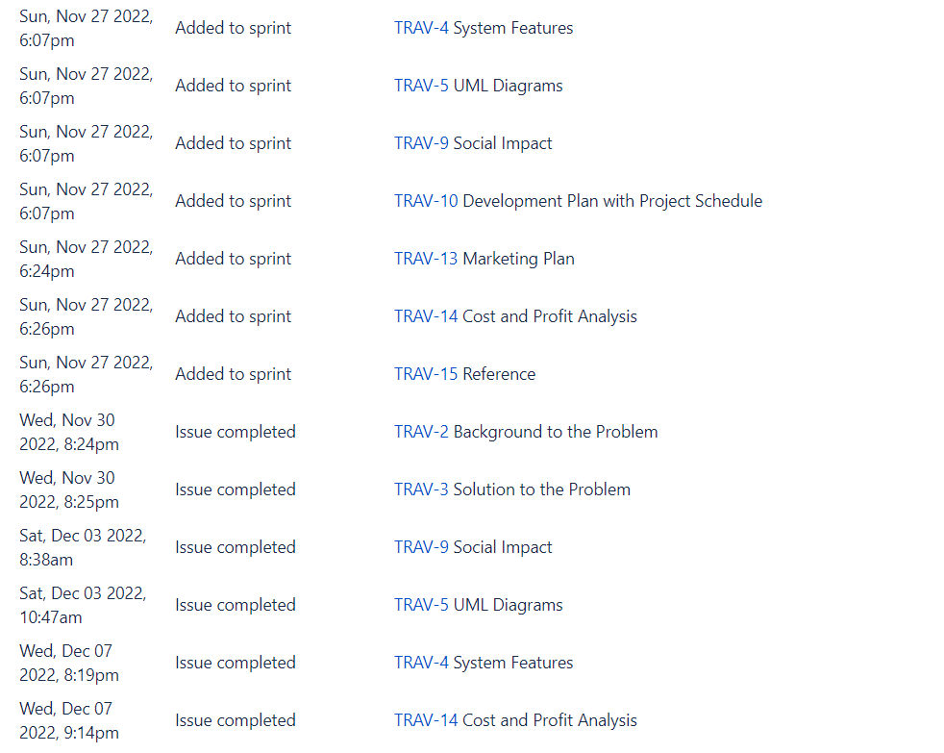

Figure 6 : Management Tool Log

**5. Marketing Plan:**

**5.1 Short Term Plan:**

A business cannot function without marketing. We'll start by concentrating on social network advertising or social media targeting for promotion. On social media, people frequently share personal information, and this data is stored and used by advertisers to create target audiences. We can use the ad services offered by Facebook, Instagram, Snapchat, Twitter, LinkedIn, Whats App, and YouTube for that. It will make it easier for us to find and connect with travel enthusiasts. To capture the interest of customers, we can create online video advertisements (OVC).

**5.2 Long Term Plan:**

We can also work together with social media influencers for promotion (such as travel vloggers) and designate them as our brand ambassadors. Our branding will benefit from it.

**5.3 Continuous Plan:**

'Advertising umbrellas' can also be used for outdoor marketing, particularly in popular tourist areas. Additionally, we are able to advertise on LED screens all over the cities.

**5.4 SWOT Analysis, Competitive Analysis, Target Audience and Marketing Strategy:**

*Figure 7: SWOT analysis for marketing plan*

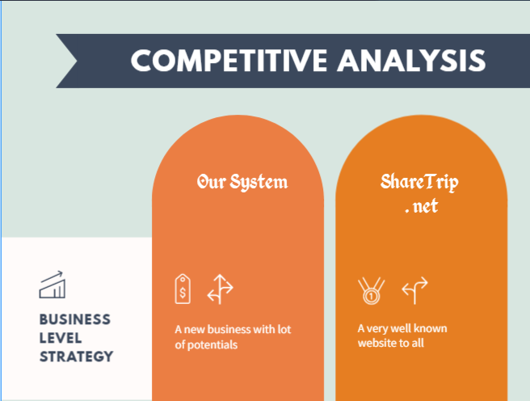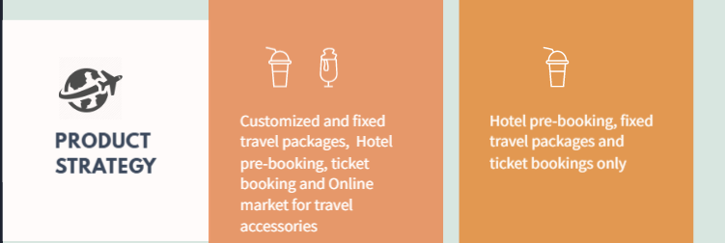

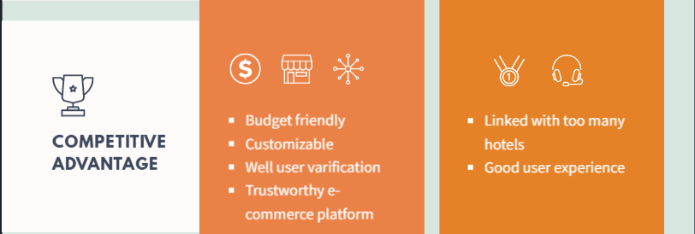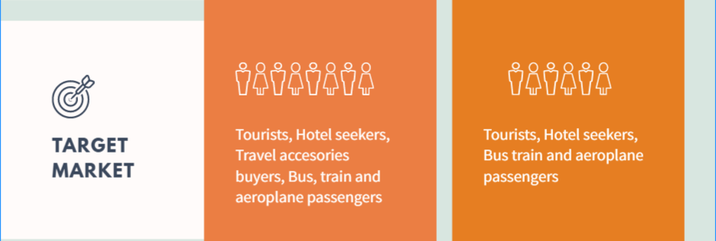

*Figure 8: Competitive analysis for marketing plan*

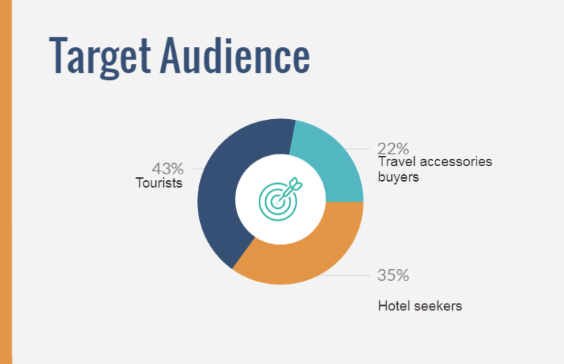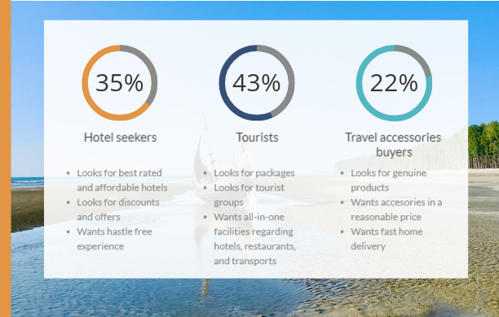

*Figure 9: Target audience for marketing plan*

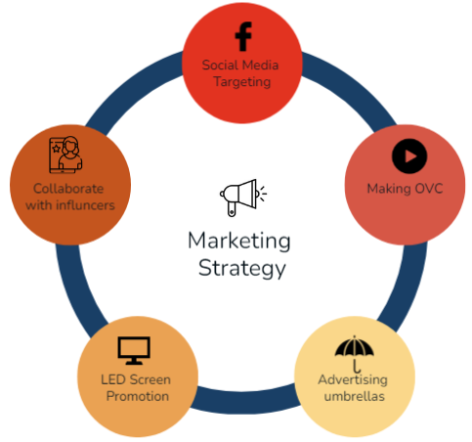

Figure 10: Marketing Strategy

**6. Cost and Profit Analysis:**

**Constructive Cost Model:**

Project Type: Organic

Coefficient: 2.4[P=1.05; T=0.38]

SLOC (Source line of code): 5000 Lines

Person Months, PM: (2.4*(5000/1000)1.05) =13.005

Development Time, DM: (2.5*13.0050.38) =6.626 =7 Months =1232 Working

Hour Required People, ST: PM/DM= 1.85 = 2 People

*Budgeting*:

Developer Salary in 7 Months:

Per developer salary per working hour =500 Taka

Total Developer Salary =500*1232 = 616,000 Taka

Requirement Analysis:

The time needed 1 month (22 working days=176 working hour)

Requirement analysis person’s hourly wage =200 Taka

Total requirement analysis expense = 200*176 = 35,200 Taka

Transportation cost estimation: 8,000 Taka

Training & hardware expense estimation: 100,000 Taka

Rent expense:

Room per month =12,000 Taka

Total in 7 months =84,000 Taka

Total utilities in 7 months: 22,000 Taka

Maintenance (Till 5 months after delivery):

Expense per hour =1,000 Taka

Total estimated time needed for maintenance =50 hours

Total estimated maintenance expense =60*1000 =60,000 Taka

Project Manager Salary:

Per month= 20,000 Taka

Total in 7 months = (20000*7) =140,000 Taka

Accountant Salary:

Per month salary =8,000 Taka

Total in 7 Months = (8000*7) =56,000 Taka

Marketing Cost:

Total in 7 Months = 100,000 Taka

Total estimated expense:

616,000+35,200+8,000+100,000+84,000+22,000+60,000+140,000+56,000+1000,000

= 2,121,200Taka

Profit:

20% of Total estimated expense =2,121,200*20% =424,240Taka

Project Budget:

1,121,200+424,240= 1,545,440 Taka

|  |  |  |
| --- | --- | --- |
| **Area** | **Time Span** | **Cost (BDT)** |
| Developer Salary | 7 Months | 616,000 |
| Requirement Analysis | 176 working hours | 35,200 |
| Transportation cost estimation | 7 Months | 8,000 |
| Training & hardware expense estimation | 7 Months | 100,000 |
| Rent expense | 7 Months | 22,000 |
| Maintenance | Till 5 months after delivery | 60,000 |
| Project Manager Salary | 7 Months | 140,000 |
| Accountant Salary | 7 Months | 56,000 |
| Marketing Cost | 7 Months | 100,000 |
| Total estimated expense | 7 Months | 2,121,200 |
| Profit | 7 Months | 424,240 |
| Project Budget | 7 Months | 1,545,440 |

**7. References:**

1. ShareTrip .Net ( <https://sharetrip.net> )
2. Pathfriend tour operator ( <https://pathfriend-bd.com/> )
3. NijhoomtTours (<https://nijhoom.com/>)
4. Constructive Cost Model (<https://www.researchgate.net/publication/353436976_Constructive_Cost_Model_II_Metrics_for_Estimating_Cost_of_Indigenous_Software> )
5. Tech Cloud Ltd (<https://techcloudltd.com/project/city-porter/>)
6. TopAgency.com (<https://topagency.com/glossary/market-umbrella-definition/>)
7. Digiviger .com (<https://digivizer.com/blog/social-media-ad-targeting-guide/>)
8. <https://icehrm.com/blog/benefits-of-a-free-travel-management-system>
9. <https://www.projectmanager.com/guides/project-scheduling>
10. <https://www.trip.com/>
11. <https://www.booking.com/>